Economic Relations Division
Ministry of Finance

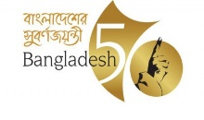

Press Release on Signing of a Financing Agreement with Asian Infrastructure investment Bank for
‘IDCOL Multi-Sector On-Lending Facility Project’

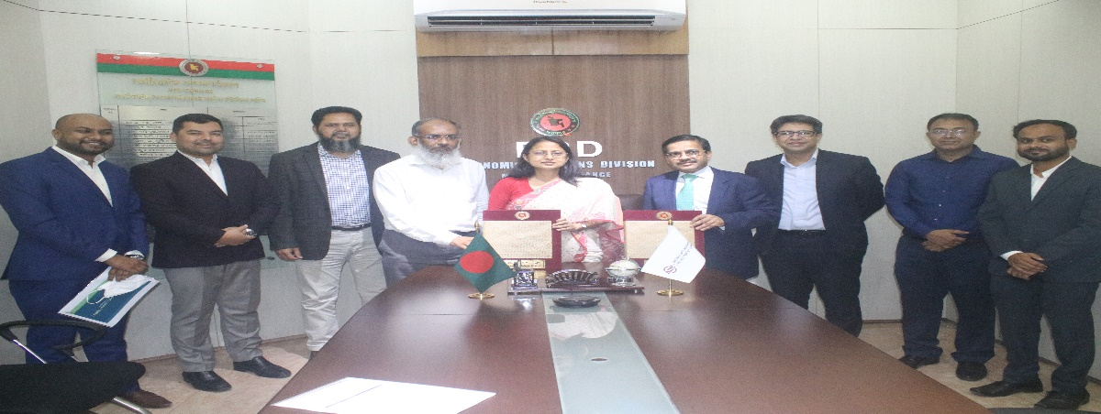

The Government of Bangladesh signed a Loan Agreement of USD 200 (two hundred) million with the Asian Infrastructure Investment Bank (AIIB) on 26 April 2022 to implement the ‘IDCOL Multi-Sector On-Lending Facility Project’. Mr. Md. Shahriar Kader Siddiky, Additional Secretary, Economic Relations Division and Mr. Dong Ik lee, Director General, Investment Operations, AIIB signed the Loan Agreement on behalf of Bangladesh and AIIB respectively.

The objective of the project is to promote infrastructure investment by providing long-term financing to the private sector in Bangladesh. It is aligned with Bangladesh’s goal to bridge its infrastructure deficit and achieve sustainable growth, as highlighted in Bangladesh’s Perspective Plan 2021-2041. The project will be financed by a loan to the People’s Republic of Bangladesh (Bangladesh), which will be on-lent to Infrastructure Development Co. Ltd (IDCOL). IDCOL will further on-lend the amount to private-owned companies (sub borrowers) in Bangladesh to support eligible infrastructure projects. The project will provide IDCOL with additional resources for long-term financing, given the huge market requirement and the need to scale up the availability of long-term financing for infrastructure projects in Bangladesh.
The loan will be received in standard terms and conditions of AIIB. The repayment period of the loan is 18 years including 5 years grace period. Payable front end is fee is 0.25% and commitment fee is 0.25% per annum for unwithdrawn amount. Rate of interest of the loan will be 0.60% + borrowing cost margin (variable) of AIIB.

Kawshar Jahan
Deputy Secretary
Phone:029180876

